**P&G Smart Learning Report**

ASIA / AKASHI / BABYCARE / PS / P&E

**Author**: Yuki Oku **Report Date**: March 29th,2021

**Co-Author:** Miki Shimada

**Author Level**: Researcher

**Title**: Baby Care How to enable Mainline tape production on Premium tape converter in Akashi

**Summary**: This share how to enable MoP (Mainline on Premium) happening in Akashi, describing the details of product formula harmonization, equipment & process scope. MoP can generate several benefits: (1) the big saving by increasing the line utilization enabling both Mainline and Premium product on the same line, (2) less inventory of the material or equipment spare because of line, formula harmonization, and (3) less resource for platform or initiative management enabling Mainline FADO.

**Business Background**

Mainline Taped volume in Japan is projected to be 92-93IYA in next 3Y due to 1) declining birth rates 2) declining Taped category (90-95 YoY) due to earlier Taped to Pants conversion. At the same time, Premium GC PRC volume will be repatriated from Akashi Premium lines to GC local production. This results in underutilization of 2 of the production lines in Akashi and feasibility to shut down these 2 lines.

This initiative plan proposes to shut down two of Akashi Mainline Taped Lines by enabling Mainline Taped production on Premium lines (MoP). MoP project generates structural benefits in Akashi MOE fixed costs in coming years via out-of-pocket savings in People, Utilities and M&R, on top of depreciation savings of 2 Mainline Tape lines post FADO.

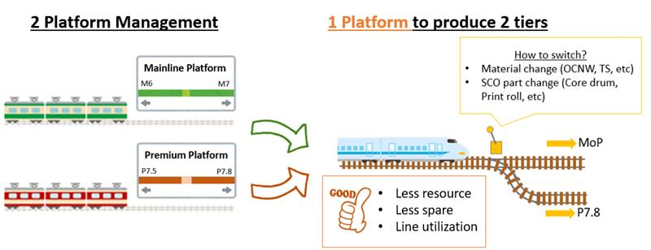

**Product scope**

MoP will launch the below formula change as blind shipment having the soft conversion from M7.

* Continue to use visible product cues of ML: 19gsm OCNW, 12gsm TS and tape design as fastening system.
* Reapply Premium hardware related formula execution: Non-channel CS10, Chassis dimensions, Elastic placements, glue placements and glue material. Keeping TS (P-10), and Non-shaped rectangular Tape.
* Reapply Premium Clear PAC glue, instead of Blue PAC glue.
* Apply UBEL.
* Keep M7 AGM level, core bag length while apply Premium CS10/AQL design



**Overall Project Schedule**

Project kick off was held in Nov’20 to enable mainline shutdown in end of FY2021.

The base plan is to shut down 1 mainline (Line31) at end-Jun’21 and another mainline (Line34) at end-Aug.

Conversion strategy

MoP conversion will happen by 2 phases.

Phase1: Only for Size1/2 only to avoid build up after Line31 shut down. Blind shipment with M7 package.

Phase2: For all sizes (Size1/2/3/4). Launch as initiative with Hard conversion claiming the product innovation (UBEL, high CS10 amount, 15gsm cuff).

EO learning

The 1st EO was done in Dec’20 with Size3 to confirm (1) the impact on pad/packing dimension and (2) process learning by running MoP formula on Premium line.

The 2nd EO was added to assess the packing dimension impact with Size4, as a corner. As the result, we concluded that pad became longer with longer CS10 design, requiring Size4 poly bag and shipper dimension change for Phase2 package.

|  |  |  |  |  |  |  |  |  |  |  |  |  |  |  |  |
| --- | --- | --- | --- | --- | --- | --- | --- | --- | --- | --- | --- | --- | --- | --- | --- |
|  | Nov’20 | Dec’20 | | Jan’21 | Feb’21 | Mar’21 | Apr’21 | May’21 | Jun’21 | Jul’21 | Aug’21 | |  | Feb’22 | Mar’22 |
| SIMPL | PE |  | |  | PC |  |  |  |  | LPA |  | |  |  |  |
|  |  | EO1 | | EO2 |  |  |  |  | Ph1 SOP |  |  | |  | Ph2 SOP | Ph2 SOS |
| Line31 | Production of M7 Size1/2 | | | | | | | | | SD | | | | | |
| Line34 |  | | Production of M7 Size2/3/4 | | | | | | | | | SD | | | |

**Key Challenges/Findings**

1. **Combination of urine leakage relation product design (BS, Cuff, Chassis Gluing)**

MoP design principle was the reapplication of dimension & material combination from the past initiative to (1) avoid urine leakage by applying the demonstrated product design and (2) minimize the capital investment by utilizing the current Premium or Mainline equipment.

Another consideration is the process difference between Mainline and Premium. Especially chassis combining process is totally difference therefore product design also differs between P7.5 and M7 (Fig.1). Then our MoP decided to harmonize chassis design to premium because we use Premium line.

**Fig.1 - Chassis Combining Flow**

|  |  |
| --- | --- |
| P7.5 e-Classic/Akashi MoP  Combine BS after TS combining | M7 e-Classic/e-Lite  Combine TS after BS combining |

**Chassis Gluing**

|  |  |
| --- | --- |
|  |  |

**Back sheet film width choice**

According to products scope table, the BS film widths for Size3/4 between P7.5(206mm) and M7(190mm) are different. Thus, there were concern of urine leakage by different film width, chassis gluing design. However, harmonizing to premium width was disaster for financial point(+8cents). Thus, it was needed to study the past initiative design (BF6, P7, P7.5) to know the demonstrated cuff design, glue design with BS Film 190mm and to contact platform R&D for leakage risk assessment. As study outcome, 190mm width film and premium chassis design combination was already demonstrated at Bolt Frog 6 initiative and could enable 190mm width film.

1. **Folded Product Dimension Change and Improve Pad Shape**

In the EO1, we found folded pad dimension became longer(stack height) vs M7 and pad shape improving(less wrinkle vs M7). Probably, chassis stiffness is improved by CS10 area expanded(longer CS10). The way of verification is run and check the folded pad length and stack height with different length, CS basis weight.[Hypothesis]

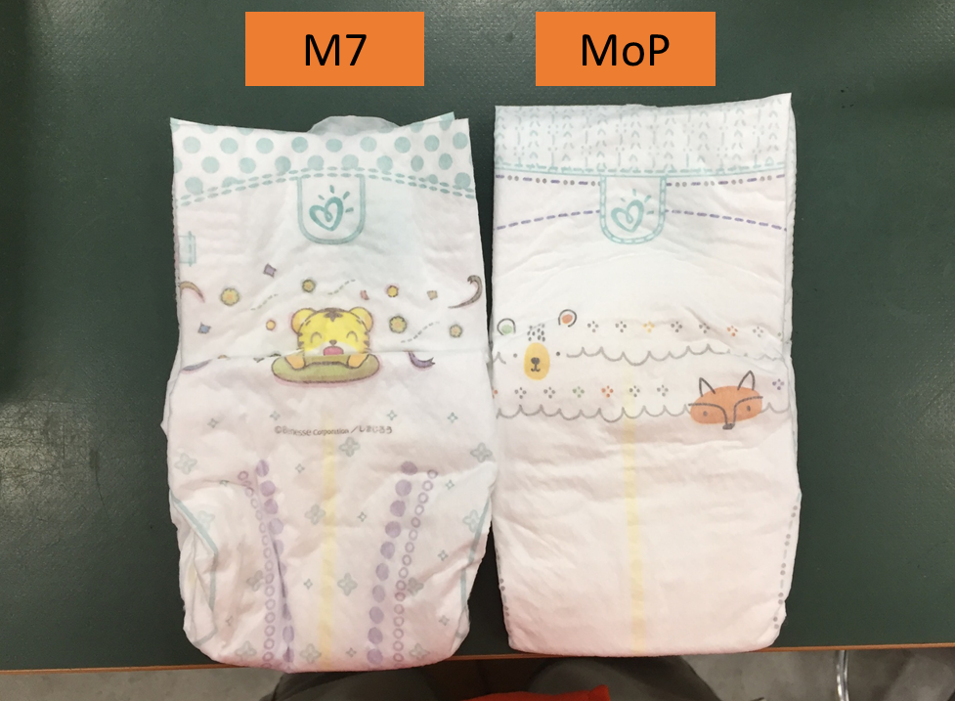

1. **Product Formulation**

Designing MoP product, it was almost same situation as creating new product. Because of there are a lot of differences between P7.5 and M7, and MoP is these mixed up product. Thus, product design deep dive session to decide design basis, material balance, measurement one by one before starting Formula Card working is required. Also, some of design are came business relative things(avoiding capital investment, change over time reducing etc.), so it is most important thing that P&E think about product design together with R&D.

**Appendix 1) EO#1 on Dec’20 Packing Summary**

|  |
| --- |
|  |

**Appendix 2) Working Document Example for Product Formulation P&E and R&D**

|  |
| --- |
|  |